**SERVICENOW SYSTEM ADMINISTRATION TRAINING–2**

ServiceNow is all about managing tasks. ServiceNow platform helps us to get all those tasks done across the enterprise.

**Task Management:**

**Topics to be covered:**

* Task assignment
* How to collaborate to complete a task
* How to manage different tasks

**What is a task?**

A task is any record that can be assigned or completed by a user. Users create tasks and are notified as the task moves along a workflow. Tasks can be assigned to specific users or user groups.

**Task workflow:**

For example,

So, this is what task management is about. You can track the progress of any work assigned to any individual or team.

**Task table:**

It is one of the core tables in ServiceNow. Any table that is a type of task is mostly extended from a task table like an incident table, request table, and change table.

**Functionalities associated with tasks:**

* Approvals: which is dependent on the requirement so a task can be assigned for approval or multiple approvals which can be generated manually or automatically as per the approval rules.
* Assignments: tasks are supposed to be assigned to someone so that somebody can work on those tasks and perform some actions as per the type of task. This can be done by some sort of rules called assignment rules.
* SLA (Service Level Agreement): it is used to track the services provided by any team working on a task SLA highlights if the duration of work completed is asking for the agreed timelines or not else SLA will be treated as breached.

**Task assignment:** A task can be assigned to a group or a user now that the user should be part of the group so that he can work on the same task but at the same time user who has been assigned that particular task should also have access on that particular task for the task record as well.

Now let’s explore more about this.

As you can see here is a core table. From this core table you want to access the list which has tasks in their extends table.

This is the parent table from the core table.

Now you can see the core table which contains “task” in the extends table column.

**Ways of task assignment:**

Tasks can be assigned to a group or a user in different ways:

1. Manually: in which a user can assign the task to himself or his group or another system user can assign it to another user or group of the system.
2. Assignment rules: they are pre-built functionalities that support setting the value assigned to an assignment group field on the task record. That is also automatically based on some rules defined by admins.
3. Predictive Intelligence: It is a feature of the ServiceNow platform based on machine learning that reads the existing historical data and updates the fields like “assigned to” and “assignment group” which means it is based on machine learning.
4. Custom rules or Scripts: administrators and developers can create their custom scripts and rules to update the assignment group and assign to automatically on the daily basis of some condition that is provided as part of the business requirement.

**Notifications:**

1. How the ServiceNow platform sends notifications to users on different events
2. How can you manage users notification
3. How can you create a new notification
4. Inbound and outbound actions
5. Inbound when records are created

**Outbound and inbound actions:**

When records are created, updated or any event is generated ServiceNow can send notifications to the users configured in those notifications ServiceNow sends a notification that is received by a user. This is called outbound notifications.

For example, incident is assigned to a group then all group members will get an email notification about the assignment of the ticket in their queue users can also respond to the email received or create a new email and send it to ServiceNow which can perform some action on the records of the table which is called inbound action.

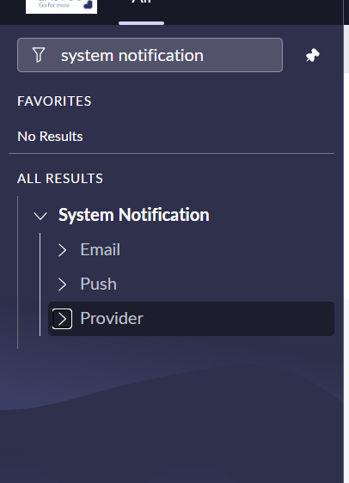

**Digest intervals** in which you can define the intervals for digest email functionality. Email digest is used to reduce the number of emails sent to the users for specific notifications in a given period if digest email is selected then instead of sending multiple notifications whenever notification conditions are met users will only receive a single notification which is sent in a specific period and that period you can mention.

**Notifications** that show the list of notifications of your instance. These are all out-of-the-box notifications. You will also see a new button at the top and you can create a new notification with the help of this button.

**Notification email scripts** show the list of email scripts for notifications. These are all out-of-the-box email scripts.

**Notification Categories** ServiceNow has created out-of-the-box categories for notifications and provided the option to select a category for various notifications on the notification form. this helps to identify your different notifications in the instance and this module shows the list of categories that are out of the box you also have this new button so if you want to create a new category for your different notifications you can do that as well.

**Templates** This module shows the list of all email templates created for different notifications email templates are reusable content for the subject and message body. ServiceNow admins can create these templates and use them in different notifications.

**Notification filters** this shows a list of filters for notifications users can filter the notifications by applying them in notification preference you can click on the settings button at the right top then you will see a pop-up, you must click on notification. Once you click that you will see a list of notifications and what type of notification you want to select.

**Notification form:**

**Knowledge article:**

It is a record in a knowledge base that provides information to users. A knowledge article can be a policy, self-help tips, troubleshooting, and resolution steps.

Knowledge management is the practice of managing knowledge articles with a defined process in the organization it has a lot of benefits:

* One-stop shop to find answers.
* Provides a centralized location for creating, categorizing, and viewing articles.
* Stores information in knowledge bases.
* Articles are referred to as KB articles.

**Knowledge Management workflow:**

**Service catalog:**

* What is the service catalogue
* Benefits
* Catalog items and categories
* ServiceNow catalog workflow
* Service catalog tasks
* And try to create catalog items

**What is a service catalog?**

the service catalog is a request order system to request services and products offered by different departments of any organization example, the hosting team provides cloud computing services where users can request for cloud servers.

**Benefits:**

* One-stop shop to request different services provided by all the departments of the organization
* Categorized items help users to request the right service.
* Multiple catalogs can be created.

**Service catalog categories:**

Services and products of the service catalog are divided into logical groups which are called categories For example you have software office supplies desktops peripherals.

**Service catalog – catalog items:**

Catalog items are the services and products offered by different departments of the organization catalog items are forms that users submit to raise any request and these catalog items create tasks for different themes.

As you can see we have this developer laptop, now it is an item provided by one of the departments and that would be for sure the department. So, as an employee, if you want to request any new laptop you don't have to reach out to any different teams via email chat, or phone you just need to go to the service catalog see the service go to hardware check this laptop if you're a developer then it's request for this service and that is what catalog item which is kind of a service a product where users which users can request and get the service.

**Service catalog roles:**

It has 4 major roles:

1. Admin: this is assigned to the system administrator who has access to most of the applications and modules and can configure any application in service now. similarly, the admin role user can also configure the service catalog he can create catalog items manage can edit them as well
2. Catalog admin: he is a catalog administrator now this user can manage the service catalog application which includes catalog categories and items but not scripting functions that means catalog admin cannot do scripting which is done by ServiceNow administrators who have admin roles.
3. Catalog manager: who can edit and update a service catalog as well as categories and catalog items within that catalog now catalog managers can assign editors as well and they can also assign different managers for that service catalog.
4. Catalog editor: who can edit and update a service catalog and they can also edit categories and catalog items within that catalog. now catalog editors can assign other editors but they cannot change the catalog manager while the catalog manager can add a catalog manager but the catalog editor cannot do that so these are the different roles to manage to configure the service catalog and service now.

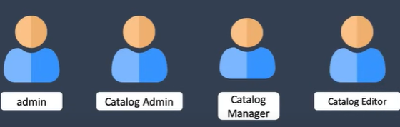

**Tables and fields:**

Stores data in the form of a database structure and it has components like tables records and fields.

In this we will learn about:

1. Tables and fields
2. How data is stored in ServiceNow
3. Tables relationship
4. Custom and core tables
5. Creation of a new custom table

Everything is managed via database structure and service now you have tables which is a database component that stores records. Then you have records that are stored in a table and these records have fields that show the information about that record. Then you have a list that shows the records in a table the list of records that records you have in that table is what you can see in the list.

**Tables:**

* A table is a collection of records in the database where information can be entered.
* Tables have different roles and these individual rows correspond to a record in a table.
* Tables also have columns which correspond to a field on a racket or row.
* These are the fields on the form now apart from these fields of racket every record of a table in service now is also identified by a 32-character unified id which is called cis id and that's unique for every record of a table.

**Fields:**

A field is a column of tables that stores the actual data can be of different types like string choice reference true or false the major attribute of fields are field label which is the display name of a field for end users. Field name is a kind of back in the name of a field and is used in scripting as well and then we have field value which is the data for a racket stored in that field.

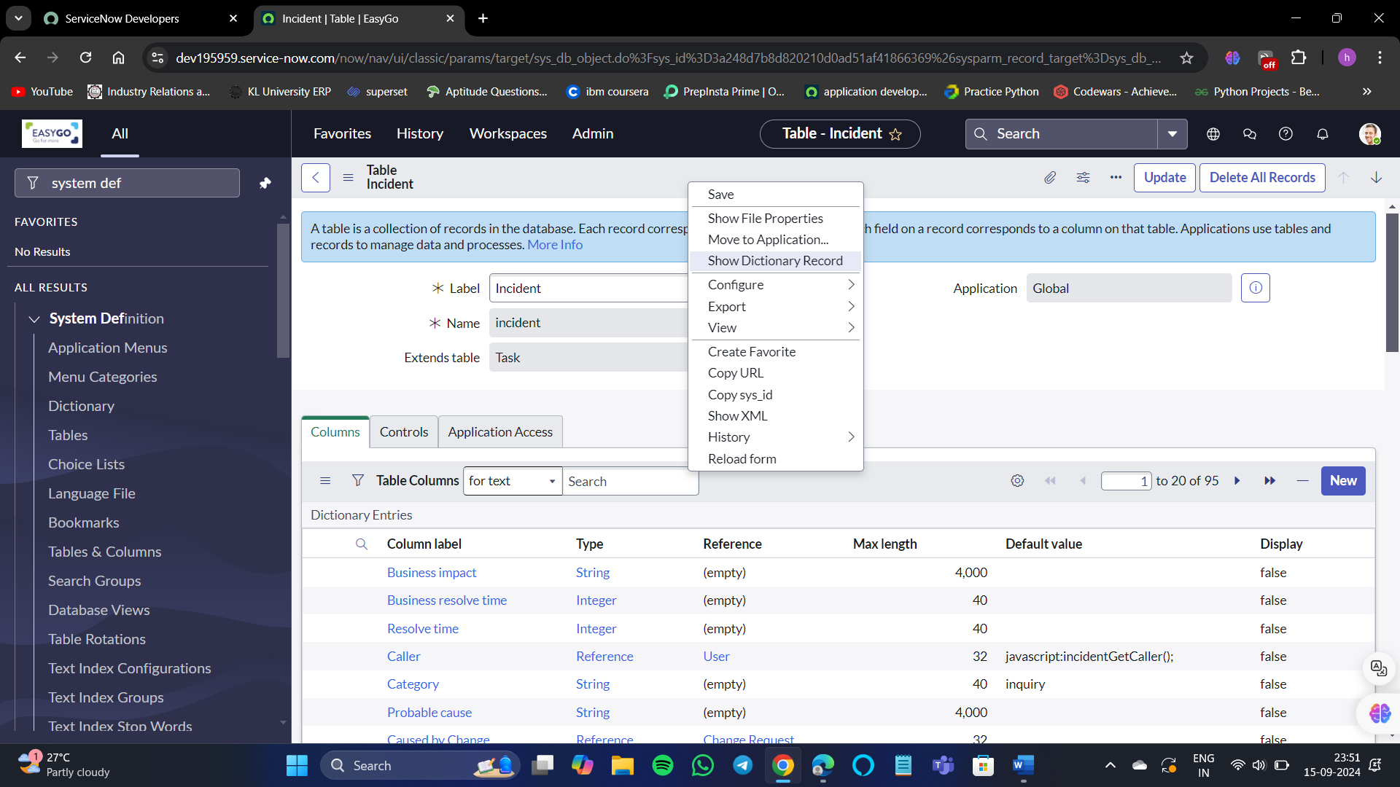

Select show list.

**Table relationships:**

As you have different tables in service now these tables can also be related to each other in different ways:

1. One to many
2. Many to many
3. Extended

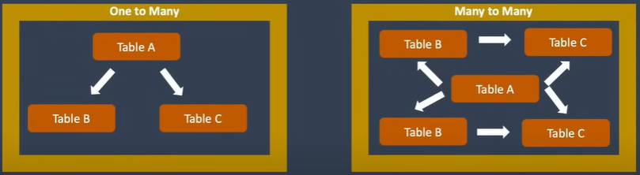

**Types of tables:**

ServiceNow has different types of tables which are categorized as per the structure they have ServiceNow administrators and developers need to know which type of table they want to meet the business requirement before starting the development and creation of a table these tables are:

**Access control list(ACL):**

ServiceNow has different levels of security to access data ServiceNow this accessibility of data can be controlled with the help of ACLS.

**Types of permission:**

1. Login
2. Application and modules
3. Tables and records

**Access control:**

Access control is a kind of security rule that is defined to restrict the permission of a user to interact with tables and records moreover data we have in ServiceNow.

It is the highest level of security that can be applied at table level record level which is called a row level axis and then we have field level which is called column level access.

**Operations restricted:**

Several operations can be restricted with the help of access control rules for users like crude operations which is the basic operation for any database.

**Security modules:**

ServiceNow provides three modules where you can do configurations for security permissions of the platform.

1. System properties
2. System Security – high-security settings
3. System security – Access control(ACL)

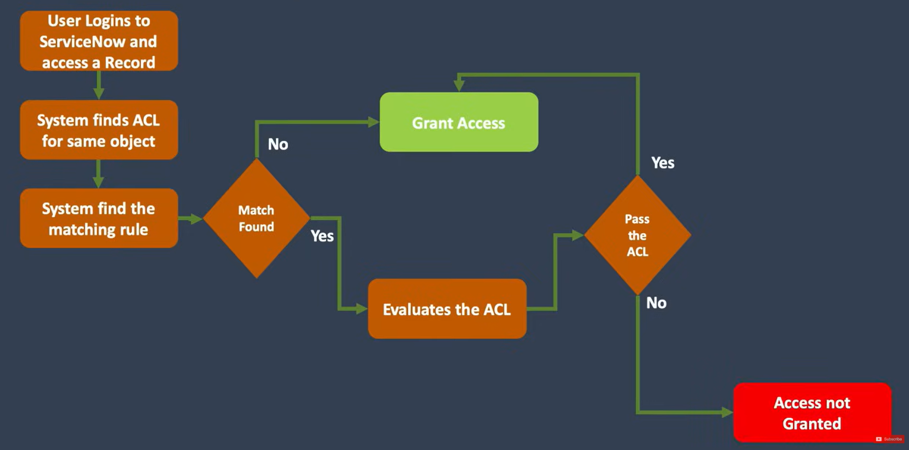

This is how ACL works.

**Data Import**

ServiceNow administrators and users can import data into different tables of ServiceNow.

**Need of data import**

You might get the requirement from different users to bulk upload the data into service now in different tables so that you don't need to do manual creation of those rackets as an example you can import the data from active directory users and groups data can be imported from active directory which get inserted or updated into user or group table respectively you can also import data from hr system some organizations they also import employees data directly from hr system into servicenow you can import knowledge articles so you might need to import knowledge articles from external system or word documents or any other format you would also get the requirement to import import assets you might need to pull assets information for another system or applications and put them into asset management table or cmdb tables.

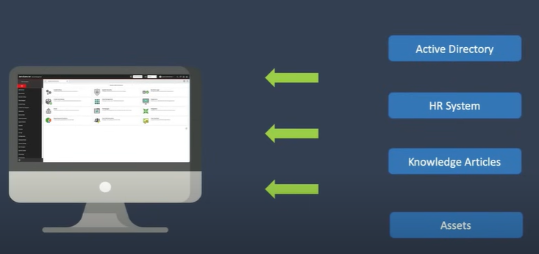

**Ways to data import:**

1. Import XML file
2. Import
3. Import sets

**Import sets components:**

1. Data source
2. Import set table
3. Transform map
4. Mapping assist
5. Coalesce
6. Target table